**Part 1**

1. Football players much meet the following three conditions:  
   Age: at least 18 years old  
   Height: at least 70 inches  
   Weight at least 180 lbs
2. Prompt the user for their age, height, and weight. Display back to them whether they can play or not. If they cannot play, display which criteria they failed and by how much.
3. A sample of the I/O is below:

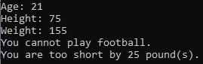

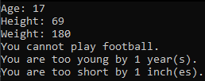

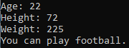

**Part 2**

1. Write a program that will ask the user for the cost of their meal.
2. The program will then ask the user which of the three sales tax percents to apply to the meal   
   (VA 5.3%, MD 6%, DC 10%).
3. The program will then ask the user how good the service was. Their choice will determine the amount of tip to apply.

Excellent service: 20%

Good service: 15%

Average service: 10%

Poor service: 0%

1. If the user chose VA or MD, the tip is applied after taxes. If the user chose DC, the tip is applied before taxes.
2. After the tip has been calculated, display the values back to the user. A sample of the I/O is below:

